Learning outcomes
- To understand different functions within a business or organisation
- To explore how the Yorkshire Dales National Park is organised

Funding, functional areas and organisation charts
Background
The Yorkshire Dales National Park Authority receives the majority of their funding from the Government the Department for the Environment and Rural Affairs – DEFRA. You can find out more here: http://www.yorkshiredales.org.uk/ydnpa/how-we-work
The YDNPA also generate some of their own income from activities and services they provide within the park for example from the National Park Centres. You can find out more here http://www.yorkshiredales.org.uk/ydnpa/how-we-work . The YDNPA could be described as a quango – can you find out what a quango is?

In order to operate efficiently the YDNPA like all business organisations regardless of their size, type or ownership is split into different areas, which carry out different tasks. These tasks are referred to as functions and can be defined as an area of activity for example human resources, finance, marketing, customer service, administration and IT support.

A business needs to be organised, so it can carry out its different functions effectively. Organisations also produce organisation charts to show who is responsible for whom, and to whom in the organisation within the functional areas.

Interaction between directorates and functional areas is extremely important. Any part of the organisations operations is likely to affect more than one functional area. The functional areas therefore have to communicate closely and work together to achieve the organisations aims and objectives. Managers are also employed to:
- Set targets and make decisions
- Share their knowledge and expertise in a particular are
- Make necessary links within the organisation and communicate between different functional areas.
A Chief Executive has overall responsibility for the organisation and is responsible for its day to day running having oversight of all the functional areas.

Activities
- We are going to focus on the school as an organisation to understand different functional areas. With a partner write a list of the different functional areas that you can think of that exist in a school. Think about:
  - Departments
  - Students
  - Support staff e.g. IT
  - Senior Leadership Team (management)
  - School office
- Now list the names of the people in school who have responsibility for different departments and/or areas.
- With a partner try and produce a diagram showing the different functional areas of the school. The diagram below might help to start you off – but make sure the diagram you produce reflects the different functional areas in your school. This diagram also shows how the school is organised.

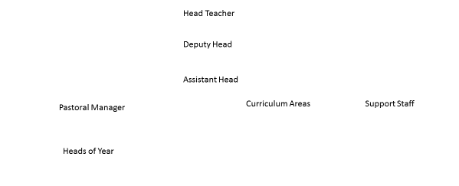

- Who in the school is responsible for the following functional areas?
  - Finance
  - Administration and ICT
  - Human resources
  - Customer service
  - Marketing and sales

Funding, functional areas and organisation of the YDNPA
- How is the YDNPA funded?
- The YDNPA could be described as a quango – find out what a quango is.
- Look at the organisation diagram of the directorate you have been allocated and also the website http://www.yorkshiredales.org.uk/ydnpa/our-people/staff discuss the following with a partner and make notes which you will able to use in your investigation into the directorate.
- What is the directorate you are investigating responsible for?
- List the functional areas of the directorate you are investigating?
- Who is in charge of the directorate?
- How many employees are in the directorate? (look at the organisation chart)
- Which directorates do you think they will need to work closely with? Why? What could happen if communication is not good?
- Who is the Chief Executive of the YDNPA – what are they responsible for?

