Each Lesson pupils relate the lesson to the synthesis of Januvia.

Lesson one
Introduction How much is the pharmaceutical industry worth?
Mercks sales last year 10.8 billion
Of this 1.3 billion is for Januvia
Januvia is
Pupils have to find out what Januvia is used for.
The formula for Januvia and how it is made.
A pharmaceutical used to treat diabetes type 2
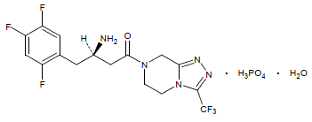

Chemical formula C₁₆H₁₅F₆N₅O•H₃PO₄•H₂O
Why is quantitive chemistry important when making Januvia?
What do you have to think about if you want make Januvia and sell
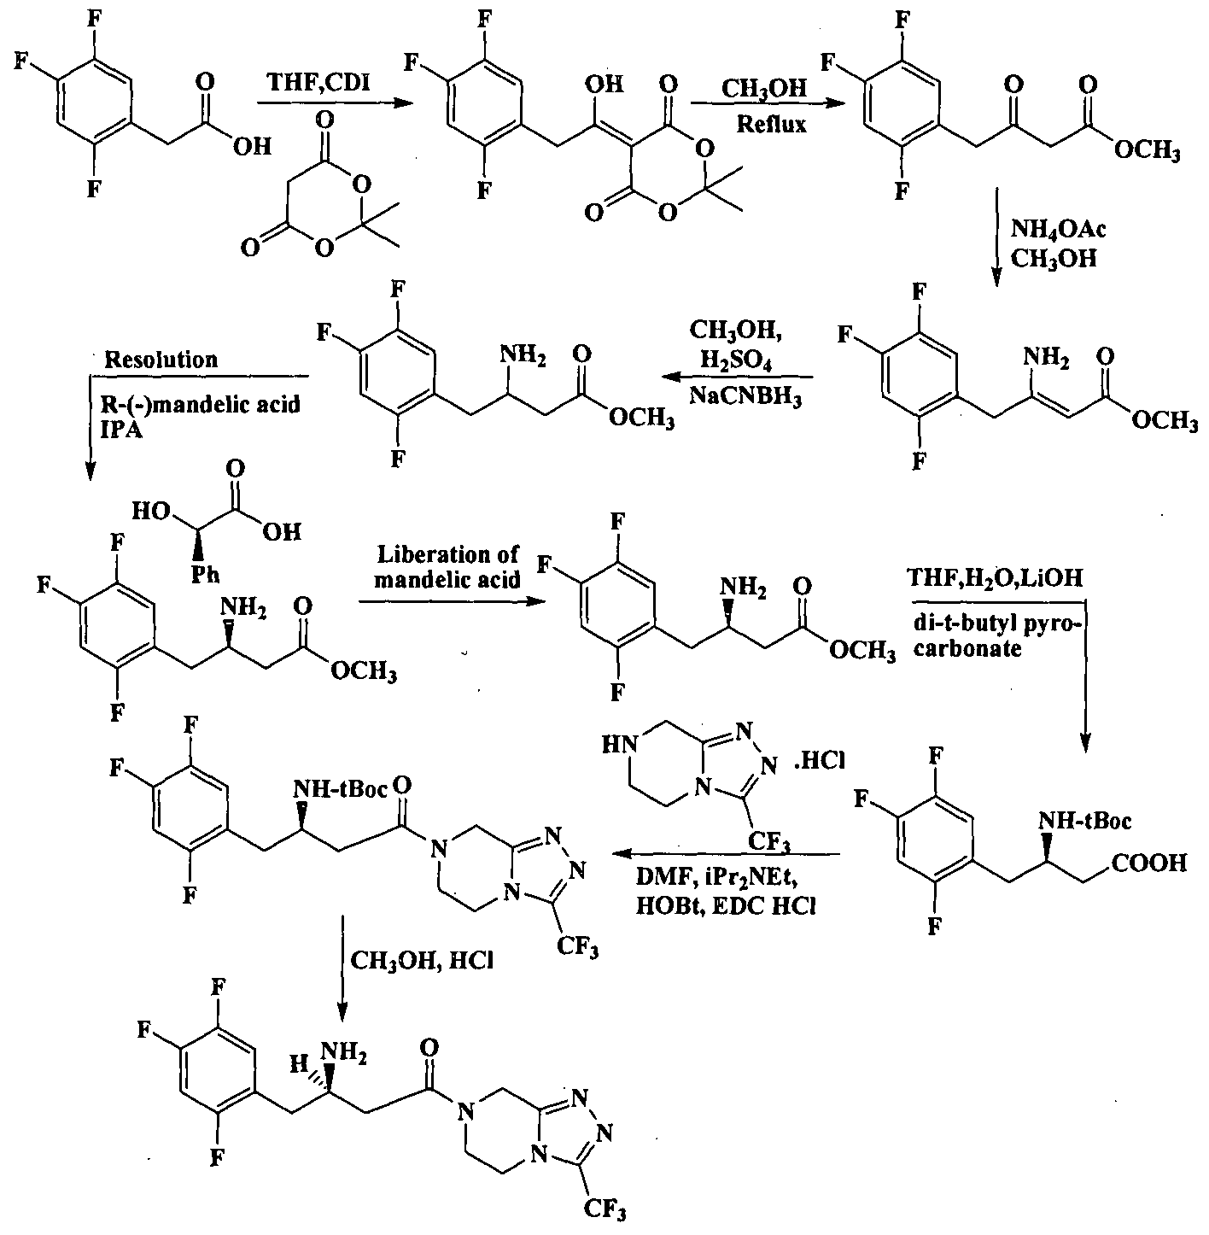
Without quantitive chemistry we won’t know how much of our starting material we will need and how much we are going to make.

Lesson 2 conservation of mass

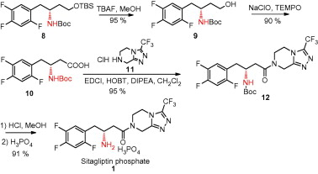
To understand how mass is conserved in chemical reactions or mass changes in chemical reactions. Reactions we can model several of the reactions in the synthesis of Januvia.
Reaction one lead nitrate + potassium nitrate.
Reaction two calcium carbonate + hydrochloric acid.
Reaction three magnesium + oxygen.

Lesson 3
Molecular mass and percentage of elements present
Demonstrate calculating the molecular mass of a compound and the percentage of an element present
Pupils practice calculating molecular mass of various compounds and the percentage of an element present

Pupils calculate the molecular mass and the percentage by mass of different elements in reactants intermediates and in Januvia.

Lesson 4 moles and reacting masses
Explain moles
Pupils calculate moles of various Janiuva starting materials and products
Explain reacting masses pupils calculate reacting mases for various chemical reactions involved in the synthesis of Januvia

Lesson 5 Limiting reactants
Explain the concept of limiting reactants
Pupils calculate which is the limiting reactant in the synthesis of several intermediates in Januvia

Lesson 6 concentration
Explain the concept of concentration and how it is measured in moles per dm3
Pupils calculate concentration moles and volume for different solutions
Extension limiting reactant questions using concentration. Pupils apply their learning to concentration questions involved in the synthesis of Januvia

Lesson 7 Percentage yield
Pupils carry out a basic synthesis and calculate percentage yield.
Pupils are given yield data for Januvia and have to calculate the percentage yield and provide suggestions as to why the yield is not 100%

Lesson 8 Atom economy
Pupils practice calculating atom economy for different reactions.
Which method of synthesising Januvia is more efficient in terms of atom economy?

Lesson 9 Volume of gas
In chemical reactions where a gas is produced what volume of gas is going to be produced? Apply this to the production of Januvia and think about the industrial implications of large volumes of gas being produced.

Lesson 10 11 Pupils prepare report of synthesis of Januvia. Looking at the cost of reactants pupils work out the cost of producing a pack off Januvia using the information and skills acquired in previous lessons. Pupils suggest ways that Januvia could be synthesised cheaper. Pupils prepare a short presentation to give to MSD.

Pupils visit MSD to research the cost of making Januvia into tablets and packaging it. They then present to MSD their report with their findings on the cost of production of Januvia.

