The online delivery and learning of vocational courses which take place in further education colleges for 16-18 years old on the Isle of Man.

August 2020

By

Andreea Pricop

Mayfield School
Introduction:
The online delivery and learning of vocational courses which take place in further education colleges for 16-18 years old on the Isle of Man.
Isle of Man is a self-governing British Crown dependency situated in the Irish Sea between Great Britain and Ireland, having a population of 85,083 ( Worldometers, 2020). Being a small island little research has been done in order to analyse the learning of vocational courses offered there, and regarding the pandemic where the whole island was forced to lockdown, education was one challenging aspects for students while their career and futures were also affected.
Education became an uncertain area in the past 5 months. Schools were forced to shut down and a lot of students remained without support in this difficult time.
Online learning became the only method of teaching, some schools could provide this type of learning for students, while most of the schools in disadvantages areas had more issues to consider, for example ensuring pupils received adequate meals and
had access to the internet. A lot of reports had been written analysing the way learning had changed in the past few months and also these reports looked at how students undertook the situation as a whole. Only 10% of the students were worried about socialising during this period, most of the students 53% were concerned about their grades and transition process into further education. ( The researcher surveyed 230 students aged 16+ in England between 28 March and 20 April 2020, University of Exeter – June 2020)[5]
This situation increased the demand for online learning, and also set the question for education providers whether they should teach students/teachers digital skills and increase the popularity for online learning.
I believe that the importance for the online delivery of studies has proven its worth in the past few months more than ever, and in the upcoming future new courses will be made and provided for students.
This research aims to determine the possible career paths in vocational courses and also the way these are delivered on the Isle of Man, having a better understanding of the possible options students aged between 16-18 year have regarding their education. Furthermore another goal was to research the job market, economy and how the students can apply their studies in future jobs and what demand for the vocational courses is on the island.
Although this report is based on the Isle of Man it could provide a baseline into the online learning of vocational courses offered, particularly in island context and remote areas.
The main research question is to understand the possible opportunities of online delivery for vocational courses, while this question has really vast borders it was divided in smaller sub-research questions:
What vocational courses are delivered on the island?
What is the profile of the college(s) or education providers (e.g. demographics, size, participation etc)?
Who are the big employers on the island and what type of employers and sectors are prominent on the island?
What are the overall employment rates, as well as rates of young people NEET (not in education, employment or training) on the island?
What is the link – if any – between vocational courses offered in the local further education college and local economy?

Methodology:
Mainly throughout the research I used document analysis which is a form of qualitative research in which documents are interpreted by the researcher to give voice and meaning around an assessment topic (Bowen, 2009). This was one the best methods to use in this case as the most information available on this topic was in the form of articles, pdf documents, texts and reports. The prime resource used was the government's website where further links were found. Google scholar was helpful for finding background information on the Isle, its economy and job market.
Quantitative research was also used as it focuses on gathering numerical data and generalising it across groups of people or to explain a particular phenomenon (Babbie, Earl R. The Practice of Social Research, 2010.) In this case was to interpret the main job market on the isle and for representing the statistics across isle on education achievements.
Another method used was interview which is a common format of data collection in qualitative research. According to Oakley, qualitative interview is a type of framework in which the practices and standards are not only recorded, but also achieved, challenged and as well as reinforced (Mason J. London, Routledge: 1994).
Limitations throughout the research were the following: there is little previous data collected therefore it was hard to identify quantitative data which supports the qualitative data found. For some of the qualitative data it was out-dated and therefore not representative of the current situation on the island.
Another issue was to gather information specifically on online vocational courses because few of those are performed on the island and there are gaps in the information provided about those from even the education providers themselves.

Findings
This next section of the report will be based on the findings found throughout my research, where I will try to answer most of the questions set above, but also include other information that I personally thought is relevant to this report.
Economy:
Financial services, manufacturing, and tourism are key sectors of the economy. The government offers low taxes and other incentives to high-technology companies and financial institutions to locate on the island; this has paid off in expanding employment opportunities in high-income industries. As a result, agriculture and fishing, once the mainstays of the economy, have declined in their contributions to GDP. The Isle of Man also attracts online gambling sites and the film industry. Online gambling sites provided about 10% of the islands income in 2014. The Isle of Man currently enjoys free access to EU markets and trade is mostly with the UK. The Isle of Man is known for the following agriculture products: cereals, vegetables; cattle, sheep, pigs, poultry and following main industries : financial services, light manufacturing, tourism
In 2017 the island had an unemployment rate of 1.1% which has fallen over the last few years from 2% in April 2011.[3] Graph 1 below shows the labour force employed in each of the main-sectors.

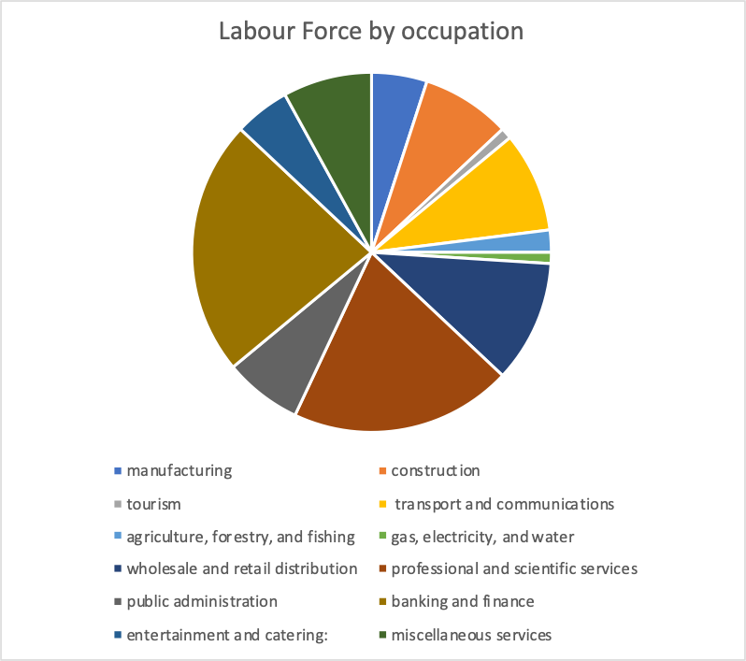
Graph 1 below shows the labour force employed in each of the main sectors.

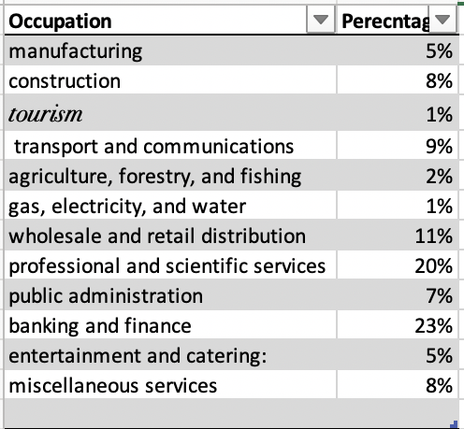

Big Employers/companies present on the island:
In this subsection I will reflect on the question from above which was: Who are the big employers on the island and what type of employers and sectors are prominent on the island?
The Isle of Man's Department for Enterprise manages the diversified economy in twelve key sectors.
The Finance sector which includes insurance, banking (includes retail banking, offshore banking and other banking services), other finance and business services, and corporate service providers together contribute the most to the GNI and most of the jobs, with 10,057 people employed in 2016. Some of the main companies on the Island are: Alliance & Leicester International, Bradford & Bingley International, Isle of Man Bank.
Another major employer on the island is eGaming & ICT. Among the largest employers of the Island's private sector are eGaming (online gambling) companies like The Stars Group, Microgaming, Newfield, and Playtech. The Manx eGaming Association MEGA is representing the sector. Licenses are issued by the Gambling Supervision Commission.
Since 1995 Isle of Man Film has co-financed and co-produced over 100 feature film and television dramas which have all filmed on the Island, therefore making a Filmmaking and Digital Media another significant sector for employment on the island.
Other noteworthy sectors include those related to electricity, telecommunications, and consumer goods.
Sixth Forms on the island and their achievements:
In the following 3 subsections I will reflect on the education system on the island starting with aged 16 and above, answering the questions:
What is the profile of the college(s) or education providers (e.g. demographics, size, participation etc)?
What vocational courses are delivered on the island?

Education is overseen by the Department of Education, Sport and Culture and regulated by the Isle of Man Education Act 2001. As of September 2017 there were 5,218 pupils in secondary education. In 2012, some 52% of students stayed on post 16 in secondary school sixth forms, where a wide variety of A level courses are on offered.
The Department of Education operates 5 secondary schools:
- Ballakermeen High School
- Castle Rushen High School
- Queen Elizabeth II High School
- Ramsey Grammar School
- St Ninian's High School
In the five secondary schools, 344 Year 13 students were entered for more than 1,000 A levels and more than 80 AS levels in over 40 subjects. ( 2016)
- In 2016 the percentage of passes at the higher grades of A*-B, was 42%. This is an increase from 2015 and the third highest on record. 7.3% of Island students achieved the A* grade, slightly down from 8% last year but still one of the highest levels since the A* was introduced in 2010.
- The number of A levels entries per student, is 3.3, which was slightly lower than previous year. In some previous years, entries have exceeded four per student but entries patterns at A level now reflect a greater focus on securing places at universities asking for three A levels grades as opposed to UCAS points.
- The breadth of subjects available (more than 40 separate titles) was proportionate with recent years. Subjects entered ranged from economics and music technology to environmental science and classical civilisations.
- In 2015 the Island’s A level pass rate was 98.1%.
- Using the UCAS tariff system (140 points for grade A*, 120 points for A, 100 for B, 80 for C, 60 for D, 40 for E) the average points score per subject entry, at 84.2 is higher than all previous years since 2010.

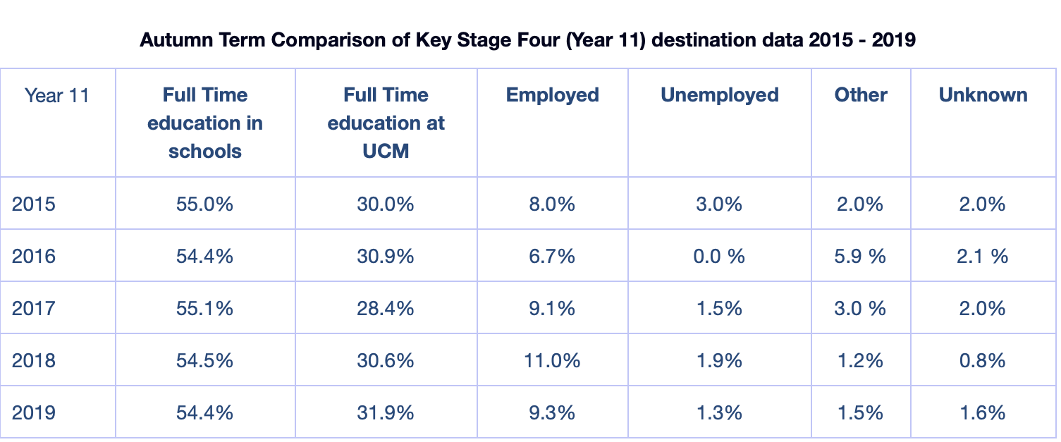
The table above presents the statistics regarding hey stage 4 and their destination pot 16, where the percentage for full time education in schools decreased with 0.6% from 2015 to 2019 and the percentage for full time education at UCM increased with 1.9%.

The college system UCM ( University College Isle of Man) and what vocational courses it offers:
UCM is the only college on the island which offers both higher and further education, which has a long-standing reputation for excellence in training and education on the Island. They offer a broad range of courses, which includes academic, vocational and professional options, as well as leisure and recreation. Starting with the age of 14 they offer a 14-16 programme, the purpose of this programme is to give school pupils the opportunity to gain a greater understanding of vocational education and the career opportunities that are available on the island. UCM also provides further education courses which cover a broad range of subject areas including: construction, business, administration and IT; art, design & media; engineering & manufacturing motor vehicles; hairdressing & beauty therapy; health & care; childcare; hospitality & catering; computing & IT; general studies and sport. Their higher education provision includes HNCs, HNDs and an MBA. Degree level courses are offered in conjunction with the University of Chester. UCM is also in charge of a wide range of courses across many subject areas with the aim of supporting collaboration with businesses across the Island. They offer the following to businesses:
- Core Services to Business training courses. This covers business enterprise; compliance and legislation; health, care and wellbeing; technical, and experienced construction contractor courses.
- Bespoke training.
- Use of our facilities and services.
- Research opportunities.
- Access to grants and funding information.
Around 30% of 16 year old school leavers go to UCM where they follow mainly vocational courses ranging from Entry Level to Level 3.
In total approximately 33% of Year 11 school leavers follow vocational courses with nearly another 10% going straight into employment.
One of the online only designed courses offered on the island is Managerial Finance provided by LSE, which is a 6 week long course with about 8-12 hours per week entirely online with weekly modules and flexible learning , while this course is informative it is not only designed for 16-18 years olds and cannot be considered as a full education programme.
Having an independent education system, Isle of Man does not follow England’s or Wales’s education system entirely. Therefore one interesting fact about the UCM is that they start their vocational courses at 14, having the programme which allows students from an early age to understand what vocational learning is, what it represents and how they can better choose their pathway in life.
Apprenticeships:
Apprenticeships are open to anyone over the age of 16, regardless of academic ability, although there may be some entry requirements for the formal study aspects of the apprenticeship. An apprentice is usually a young person, who agrees to work for a specific contractual amount of time, typically 2 years, in order to learn a craft, trade or profession with an employer. As well as learning on the job an apprentice undertakes formal training on day release from the employer at a local training provider, in order to gain a relevant, industry recognised qualification.
The Isle of Man is at the forefront of creating successful apprenticeship schemes, with real people getting real jobs at the end of their formal apprenticeship contract. The employed.im team currently supports apprenticeship programmes for ICT (MICTA) ( Manx ICT Association). It is 2 years long offering part time study at the UCM and a job vacancy in one of the digital companies on the island like DMS, IT Works, Manx Telecom, Equiom, Netcetera, Government Technology Services (GTS), MBS, Antelle, Nedbank. Also it offers support apprenticeships in engineering and manufacturing (ACE). On the island, there are many sectors and industries offering apprenticeships that are supported by the Isle of Man Government. These include Accountancy, Childcare, Construction Apprenticeships, Dental Nurses & Technicians, Farming, Finance, Hairdressing, Health & Beauty, Hospitality, Printing & Veterinary Nursing. Apprenticeships on the island are also offered by the UCM in the following areas:
Agriculture, Brickwork, Business Administration, Carpentry and Joinery, Construction Technician, Creative Arts/Media, Electrical Engineering, Electrical Installation, Engineering and Manufacturing, Hairdressing, Hospitality and Catering, Horticulture, Information Communication Technology, Motor Vehicle Engineering, Painting & Decorating, Plumbing, Sports.
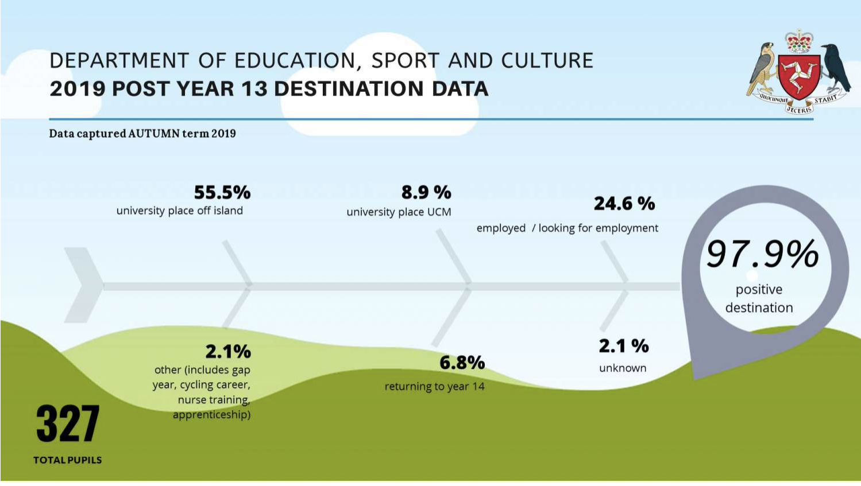
Data representing the pathways of post 18 students
Table 3.

How did Covid-19 affect the education.
Due to the pandemic the schools had to close in March 2020 and therefore several hundreds of students remained with little support on their education as most of the lessons had to move online. Until July when schools began to reopen. For more than 4 moths students were confused about their exams and studies, these series of events had a negative impact towards schoolers as the education system had not been prepared for the schools to deliver their lessons online. Although a negative part of the pandemic is the effect of disruption to education, something positive can also be seen, a lot of research and reports were started and written in the past few months looking at how education had been impacted and the idea of online delivery of studies is now more popular and looked at as an possible way to teach in schools.
Covid-19 had a significant impact towards the vocational courses offered on the island as practical courses were significantly impacted in terms of ongoing skills development and assessment – in schools but more particularly UCM. However some students on BTEC courses could continue relatively as normal because independent research to complete assignment briefs is how these courses run normally. Before the global pandemic UCM provided Resources shared on the DESC common IT platform and google classrooms.
One interesting fact to be known about the influence of Covid-19 on learners is that some of the students found home-learning much more comforting and proved to achieve better results. This set a question for the Education Department on the Island. Also some of the secondary schools on the island have the idea to organise a one week online learning in schools so they could teach the pupils how to make the most of the technology.

Conclusion:
In this section I will try to evaluate my research and come with an overall view on the topic of my research which is: The online delivery and learning of vocational courses which take place in further education colleges for 16-18 years old on the Isle of Man.
Regarding vocational online courses offered on the island there seems to be none of them currently present. While a range of vocational courses are offered, it seems to lack a direct connection between the biggest companies on the isle and the courses offered. For example eGaming became a huge source of income in the past few years while vocational course offered around IT seem to have lacks around skilled teachers and opportunities. In my opinion this sector is under development at this moment, like the new Digital Apprenticeship Scheme (2019-2020) which offers a part time study at the UCM and also a 2 year job vacancy for the following companies: PDMS, IT Works, Manx Telecom, Equiom, Netcetera, Government Technology Services (GTS), MBS, Antelle, Nedbank. As this sector is just becoming popular, time is needed in order for its full development.
In terms of business and finance, this sector is much more developed around courses and job opportunities, having much more course diversity and job opportunities.
It seems that the pandemic arose the idea and necessity for the online delivery of courses and studies which are currently viewed as possible opportunities for future, this could be viewed as a positive side effect from Covid-19.
In my opinion further research is needed and if it is to be done I would wonder on the students opinion and would include further questions such as -
- What is the student’s opinion on the vocational courses offered on the island ?
- How likely are they to choose online learning rather than face to face learning ?
- Do they feel a lack of opportunities regarding vocational courses and their interests ?
- How did Covid-19 affect their studies and their future plans towards education ?
- Overall the Isle of Man lacks online vocational courses and experts in this field, but the future looks promising with new upcoming opportunities .

References:
Current on the Isle of Man
https://www.worldometers.info/world-population/isle-of-man-population/ [1]
Babbie, Earl R. The Practice of Social Research. 12th ed. Belmont, CA: Wadsworth Cengage, 2010; Muijs, Daniel. Doing Quantitative Research in Education with SPSS. 2nd edition. London: SAGE Publications, 2010.[2]
https://theodora.com/wfbcurrent/isle_of_man/isle_of_man_economy.html[3]
https://en.wikipedia.org/wiki/List_of_companies_of_the_Isle_of_Man[4]
https://www.gov.im/categories/education-training-and-careers/schools-and-colleges/
https://en.wikipedia.org/wiki/Education_in_the_Isle_of_Man
https://www.ucm.ac.im/courses/apprenticeship/
https://www.employed.im/about-apprenticeships/types-of-apprenticeships/
https://www.ncbi.nlm.nih.gov/pmc/articles/PMC4194943/
https://signposts.sch.im/pages/index/view/id/58/Post%2016%20Destination%20Data
https://www.edge.co.uk/sites/default/files/documents/covid-19_report_final_-_web.pdf[5]

